**Assignment #1:**

**Instructions:** Copy and run the below program in your IDE of choice then take a screenshot and upload to your GitHub account. Then send me an email to: OpenSourceIt2020@gmail.com. Good Luck and good Job.

**#Enter first and last name**

**names = input("Enter first and last name")**

**print(names)**

**print()**

**#Enter your goals for this class**

**print("What are your goals for this class - long term goals?")**

**goals = input('What would you like to be....when all is said and done with the class?')**

**print(goals)**

**Assignment #2:**

**SECOND ASSIGNMENT Assuming that the first assignment worked and your program is running perfectly.**

**You are in a jubilation mode. You now want to take it a notch higher.**

**So, in your nature as a risk taker, you decided to design another program.**

**Only that this time the Program is lengthy and more meaningful. You design the following program.**

**Design a program to accept as a user input:**

**1.] Your first and last names**

**2.] Your last name**

**3.] Your country of Origin**

**4.] Enter the nature of your current job**

**5.] Enter your email address (does not have to be the real email address)**

**6.] Enter your phone number(does not have to be the real phone number)**

**7.] Enter your current city of residence (Does not have to be your current city)**

**8.] Enter your Mailing address/ Physical address (Does not have to be your real address)**

**Print out the output in the following format:**

**=============================================**

**Name:** Koffi Olomide

**Country:** Democratic Republic of The Congo

**Profession:** Musician

**Email:** Koffi.Olomide@koffiolomide.com

**Phone:** +253876564523

**City:** Kinshasa

**Address:** 654E Main Street

**=============================================**

**Once done, run the program. Let it generate the output and you capture a screenshot.**

**Upload the program and the screenshot all together to the GitHub repository then send**

**me a link with the location of the repository.**

**Nice work and good Luck !!!!!!!!!**

**=============================================**

**Assignment #3:**

Team, assuming that Project #2 worked so well and now the company you

interned with would like to extend an offer to you. Before they do that,

they need your expertise in formulating a tight knit program to help

determine the Credit worthiness of their customers before they extend loans

to them for buying a car.

Below is a working program, but with a few kinks which you, as a Python

Developer is required to clear and fix the anomalies for it to function properly.

This is the Program below with a few mistakes (Syntax and Logical errors) FIX IT:

#........ and shoot for the Sky in you getting a big promotion & opportunity

#Enter Full Names

print"Enter First and Last Name:")

fname = input(fname) #First Name

lname = input(lname): #last Name

fullnames = fname + " " + lname

#Enter phone, email

print('Enter Customer's Phone Number: ")

phone = input(phone)

print(Enter Customer's email address: ')

email = input(email)

#price of a used car

price = 10000:

has_good_credit = True;

if has_good_credit:

down_payment = 0.1 * price

else:

down_payment = 0.2 * price

print(fDown Payment: {down_payment}")

print('')

print("Full Names:", +fullnames)

print("Phone: " +phone)

print("Email: " + email)

print("Down Payment: ;, +down_payment)

This below: Is the Expected output:

**Full Names**: Bernard Njoroge Otieno

**Phone:** 872-098-9876

**Email:** UsedCarSalesman@gmail.com

**Down Payment:** 1000.00

**Assignment #4:**

YOU HAVE BEEN HIRED FINALLY BY THE 21st Century as a Senior Programmer and you've been tasked to help in revamping their credit rating and loan issuing system. Just remember, your job is to make things happen. As a Sr. Developer in Python Programming, all the lights and attention are turned towards you and there is a job to be done to deliver this critical system on time.

Your job is to design a simple program to allow the loan officer(s) to enter the customer particulars at the terminal and determine if a customer is creditworthy.

Based on their loan officer's entry, your system is required to get the best desired results as shown below in the **OUTPUT**.

Please, design a program to do the input entry, do the desired calculations and come up with the needed requirements and output them as needed.

Please consider all the needed variables. If you need to add any, please do add if need is there. Good luck.

**#Enter the price of the House you wish to Buy**

print("Enter the house price")

price = input()

**#Enter the credit score**

print("Enter the credit score")

CreditScore = input()

**#Enter the first name**

print("Enter the first name")

first_name = input()

**#Enter the last name**

print("Enter the last name")

last_name = input()

fullnames = first_name + " " + last_name

**#Enter the email**

print("Enter the email address")

email = input()

**#Enter the phone number**

print("Enter the phone number")

phone = input()

**#Enter the mailing**

print("Enter the mailing address")

mailing = input()

**#Enter the mailing**

print("Enter the City")

city = input()

**#Enter the mailing**

print("Enter the zip code")

zipcode = input()

**#Qualify for loans with the best interest rates**

CreditScore >= 780 AND 850

print "Excent Credit"

print("Zero Down Payment")

downPayment = 0.10 * price

**#Usually qualify for loans with the best interest rates**

CreditScore >= 740 AND 779

print("Very Good")

downPayment = 0.1 * price

**#May face slightly higher loan Interest rates**

CreditScore >= 720 AND 739

print("Above Average")

downPayment = 0.3 * price

**#May qualify for most loans of higher interest rates**

CreditScore >= 680 AND 719

print("Average")

downPayment = 0.6 * price

**#May qualify for most loans at significant higher Interest rates**

CreditScore >= 620 AND 679

print("Below Average")

downPayment = 0.18 * price

**#Usually has some credit issues; will probably not qualify for most loans**

CreditScore >= 580 AND 619

print("Poor Credit Score")

downPayment = 0.20 * price

**#Facing extreme credit issue**

CreditScore < 520

print("Poor Credit Score")

downPayment = 0.25 * price

==================================================================

**OUTPUT OF THE PROGRAM**

==================================================================

**First Name:** James Mutison Mutisya

**Physical Address:** 435 Hidden Special Place

**City:** Kalamzoo **State:** Michigan **Zipcode:** 49001

**New House Price:** 245,000.00

**Down Payment:** 20,000.00

**Credit Score:** 679

**Credit Status:** Below Average

CONGRATULATIONS - YOU NOW OWN YOUR DREAM HOME - James Mutison & Lucy Mutisya

==================================================================

**Assignment #5:**

You have done a very good job at Century 21st as a Python Developer. One day you saw a job advertisement for a Senior Programmer at the Canadian Space Agency on Indeed.com. Being who you are, you could not let the opportunity pass you by.

Canadian Space Agency (CSA) is an equivalent of North America Space Agency (NASA) in the USA. They’re both known for their track records for hiring top-notch Scientists. You decided to give the opportunity a shot.

Long behold you are lucky, and you actually landed the job as a Python and Database Senior Programmer/Scientist.

Your first assignment is to design a simple computer program to help convert from Metric to SI units anything you all do at **CSA** which uses the same system as any other commonwealth country.

You design a Program to come up with a software to convert:

1) Temperature from Fahrenheit to Celsius and back

2) Convert Nautical Miles to KMS and back,

3) Convert Kilometer to Miles and back,

4) Convert Centimeters to meters and back

5) Convert Yard to Meters and back,

6) Convert Inches to Centimeters and back

Your program should be menu driven with Options to pick from the running program.

Your screen should have something similar to the screenshot shown below.

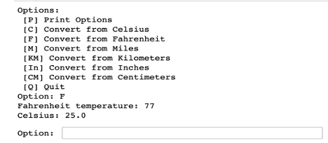

In the program, consider using Loops (**FOR** or a **While** Loop), consider using **if, elif** and **else** statements, consider declaring and using functions and methods in your design.

This program is due in 7 days from today. Good luck and good job. Consult with your Kamkunji in case of any questions.

**Assignment #6:**

A Python Programing Bootcamp in Kinshasa, DRC, is interested in offering a scholarship to her students, a class of over 500 students. They reached out to you to come to their rescue.

The following are some of the requirements. There are 3 quizzes to do, all quizzes are worth 100 points each, there are two tests each 100 points (Advanced and Expert) Python tests. There are about 10 assignments on programming and there are also 3 mandatory zoom calls to attend to help reinforce the materials.

As a boot camp, they are looking to hire you as a Python developer to put their concept into a tangible product, and into fruition.

There are two types of Scholarships

1) Full scholarship - only obtained by students in Africa

2) Partial Scholarship. – only obtained by students in the diaspora and outside Africa

The following are the requirements to earn a scholarship:

i) For a student to get a scholarship, they must come from Africa

ii) The student has to score an average of 80% for males.

iii) The student has to score an average of 76% for females.

iv) All the quizzes are added together, and the two test and the average are obtained.

v) All the zoom calls attendance are scored based on participation and attendance at 9 points total attendance and participation

vi) The programming assignments are also scored based on attempts and submissions at 10 points totals.

You are required to design a program to issue the scholarships. The program should accept entry of:

1) Student first and last name

2) Student Id number (make up your own)

3) Student mailing Address/ City / Country and Region. For African Region accept “A” for others accept “O” option

4) Student email

5) Students phone Number

6) Score obtained on Quiz, Quiz2, Quiz 3, Test 1 and Test 2 and calculate the Average

7) Display the score obtained from Zoom calls – [0 – 9] points

8) Display the score obtained from homework programming assignments [0 - 10] points

9) If the student is not based in Africa – don’t offer a scholarship. Only give to students in Africa.

10) Display a detailed report on the screen with well formatted output including the above details. Make it a good-looking report which can be presentable to the company CEO.

In this code assignment, your imagination is left for you to innovate and work the code as you would see fit with a good friendly user interface.

In the program, consider using Loops (**FOR** or a **While** Loop), consider using **if, elif** and **else** statements, consider declaring and using Functions and Methods in your design.

This program is due in 7 days from today. Good luck and good job. Consult with your *Kamkunji* in case of any questions.

**Assignment #7:**

Motorola is struggling with their Phone book for saving individual contacts on their mobile phone and tablets. So far so good, but not very well designed as the demand needs it to be more robust and user friendly. You are the brand-new Python Guru hired to help on this project to come in and rescue the situation. Without your new design the company will lose a lot of customers to her competitors like Apple and Samsung.

You want to use Python Programming language to design the code using Python Dictionary and Files Processing for permanently storing the individual contacts in a text file.

The phonebook needs to accept the following, but through a Python dictionary:

a) First Name

b) Middle Initial

c) Last Name

d) Mailing Address

e) City, Country (State), Zip Code

f) Email Address

g) Phone Number

Once the above input is entered, please insert them into a file called **contacts.txt**. Use the following method for opening the **contacts.txt** for reading/writing.

with open("contacts.txt") as file: # Use file to refer to the file object

data = file.read()

do something with data

Opens **contacts.txt** in write mode

with open('contacts.txt', 'w') as file: # Use file to refer to the file object

file.write('Mandela')

Notice that we didn’t have to write “**file.close()”.** That will automatically be called when you use the **with open** for this operation.

Make the Menu to be able to INSERT new contacts, EDIT existing contacts, DELETE unwanted Contacts, Update an existing Contact(s).

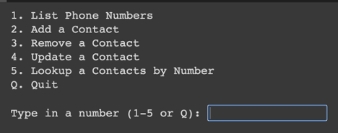

You may wanna use a menu driven function to accomplish this feat. In your arsenal are the IF…ELSE…ELIF, input(), print(), Dictionary, and use Python functions.

This program is due in 7 days from today. Good luck and good job. Consult with your *Kamkunji* in case of any questions.

**Assignment #8:**

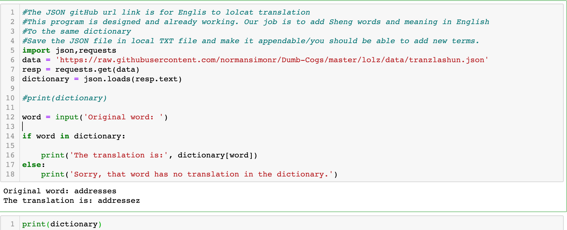

The JSON gitHub url link is for English to lol-cat translation. Lol-cat is an imaginary Cat language translation from English. This program is designed and already working. Our job here is to add Sheng words and their meaning in English. To the same dictionary Save the JSON file in a local TXT file of your choice and make it appendable/you should be able to add new terms into the text file dictionary.

Save the JSON file local to your computer. Add new Sheng terms and their corresponding translations - {"SHENG TERM" : "MEANING IN ENGLISH"}. Also separate the English Terms and the Sheng Terms in their various corresponding text files. Good Luck.

**Assignment #9:**

You finally secured a permanent job with Kenya Power and Lighting Company (KPLC) as a Python and Database programmer. As a company, KPLC recently experienced exponential growth due to the Rural Electrification in Kenya. Alot of homes in Kenya, both in Urban and Rural areas got the KPLC services. It has been hectic with the old billing system and the consumption and billing has been accurate. As a new Programmer, there is lots of hope in the design of the system you are working on. The management and the higher echelons in the company cannot wait long to see the product.

**The following are the charges for electricity per kilowatt.**

1. 1 Kilowatt of electricity is KE sh. 10.00 in Rural Area (residential)
2. 1 Kilowatt of electricity is KE sh. 15.00 in Urban Area (residential)
3. 1 Kilowatt of electricity is KE sh. 20.00 in Rural Area (Light Industrial)
4. 1 Kilowatt of electricity is KE sh. 23.00 in Urban Area (Light Industrial)
5. 1 Kilowatt of electricity is KE sh. 27.00 in Rural Area (Heavy Industrial)
6. 1 Kilowatt of electricity is KE sh. 30.00 in Urban Area (Heavy Industrial)

**As a requirement:**

1. Your program needs to enter the customer’s name whether residential/urban/rural/light Industrial or Heavy Industrial.
2. Need to input the Billing Address/ City/ Town and County
3. Calculate the total cost per month of electricity consumed
4. Print out a monthly receipt of the Kilowatts consumed, taxes paid, whether it is residential, or an industrial. Format your output as you would see it on your electric bill at home.

**The following are the conditions for the charges and the billing for the KPLC company.**

State VAT Tax (18%) charges on Industrial in Urban Areas

State VAT Tax (15%) charges on Industrial in Rural Areas

State VAT Tax (10%) charges on residential

Every city in the country charges a nominal tax of 4% on the total electricity consumed regardless. We call it city tax - 4%.

**Conditions:**

1. If monthly electric consumption is between 200kw and 450 kw then give a discount of 3%.
2. If monthly electric consumption is between 451kw and 500 kw then give a discount of 5%.
3. If monthly electric consumption is between 501kw and 601 kw then give a discount of 7%.
4. If monthly electric consumption is between 602kw and 701 kw then give a discount of 9%.
5. If monthly electric consumption is between 702kw and 801 kw then give a discount of 11%.
6. If monthly electric consumption is over 802 kw and above then give a discount of 12%.

Create the program to routinely insert into the file (electricity.txt) the details and routinely write the same into a MySQL database.

Make the Electricity.txt readable and be able to display the formatted output on the screen.

Make the Electricity MySQL database readable and be able to display the formatted output on the screen and archived records displayable and CRUD (Create/Read/Updated/Deleted).